**Design Audit Challenge – Oct 2024**

**Design Opportunities**

1. **Messages Extension**

Friction Points: the UI had a cluttered layout, with multiple action buttons ("Answer," "Follow up," "Interested," etc.) visually crowding the modal, which can overwhelm the user. The flow needs to be consistent and not have too many differences between options, so navigating is easier and intuitive (especially when it comes to word limit). Having a lot of buttons as options may confuse the user, as buttons should be minimal and used mostly as CTA.

Another problem that I noticed personally is that people who are not accustomed to certain AIs might not recognize the names, which leads to them not using them. The buttons on the top part might not be clicked or understood by the user.

Solution: Moving the Ripple icon next to the other icons makes it more intuitive for the user, as he can find anything he needs in the icon bar.

Organizing options into dropdowns and checkboxes, specifically adding the "Select Reply Type" dropdown and "Add extras" checkboxes (e.g., Emojis, Tag user). This reduces visual clutter by consolidating less-used options. Changing the word limit into a dropdown also makes the UX easier as it doesn’t allow him to choose between a fixed option and a custom one. This solution prioritizes clarity and minimizes distraction by keeping primary actions visible while hiding secondary choices in checkboxes.

I also suggest keeping the personalization option visible at all times so it doesn’t confuse the user and they know the option is available

For the accommodation with AI, I suggest using a dropdown that states "AI Tools" so the AI tools already have the AI label, and also adding an information icon that explains which tool and what is it used for. This ensures that the user understands the tools and knows how to use them as his advantage.

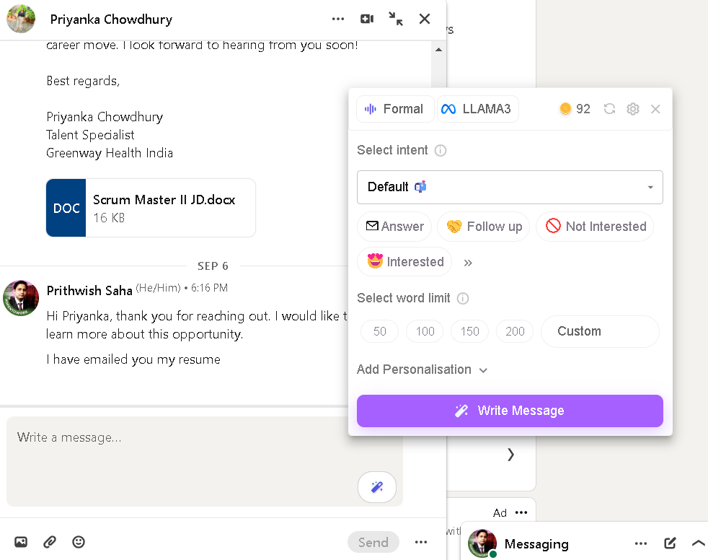

Figure 1.1. Original Design for Message Extension

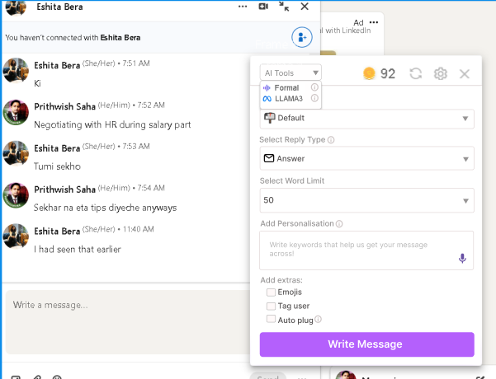

Figure 1.2. Suggested change for Message Extension-dropdown

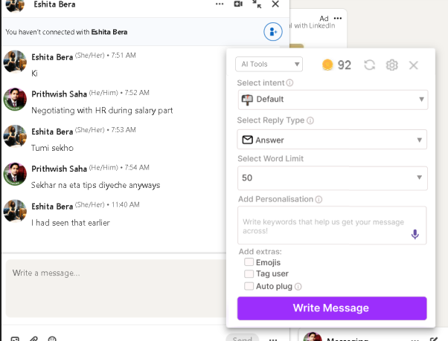

Figure 1.3. Suggested changes for Message Extension

1. **Replying to comments**

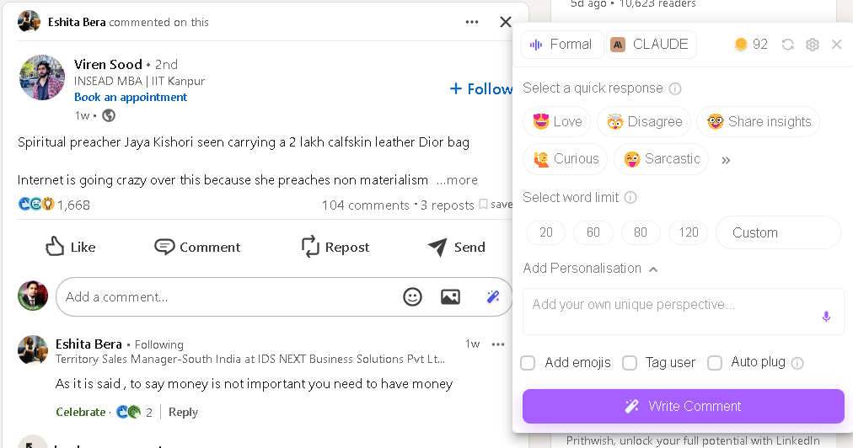

Figure 2.1. Original Design for Commenting on LinkedIn posts

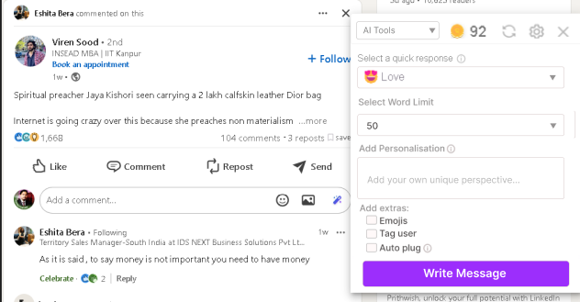

Figure 2.2 Suggested changes for Commenting on LinkedIn posts

Friction Points: the UI has a cluttered layout, with multiple action buttons ("Love," "Disagree," "Curious," etc.). The flow needs to be consistent and not have too many differences between options, so navigating is easier and intuitive (especially when it comes to word limit). Having a lot of buttons as options may confuse the user. Having a lot of buttons as options may confuse the user, as buttons should be minimal and used mostly as CTA.

Solution: Keeping the Ripple icon in next to the other icons it is an intuitive choice that was kept in the final design.

Organizing options into dropdowns and checkboxes, specifically adding the "Select Quick Response" dropdown and checkboxes (e.g., Emojis, Tag user). This reduces visual clutter by consolidating less-used options. Changing the word limit into a dropdown also makes the UX easier as it doesn’t give him the option to choose between a fixed option and a custom one. This solution prioritizes clarity and minimizes distraction by keeping primary actions visible while hiding secondary choices in checkboxes.

I also suggest keeping the personalization option visible at all times so it doesn’t confuse the user and they know the option is available.

Keeping the modal as consistent as possible throughout the extensions ensures that the user gets familiar with the design and can use it intuitively even if they haven’t tried a certain extension at that moment in time.

1. **Profile Checking**

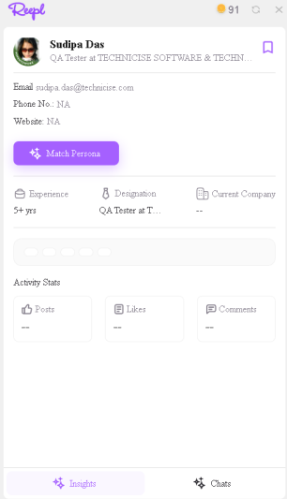

Figure 3.1. Original Profile Checking Design

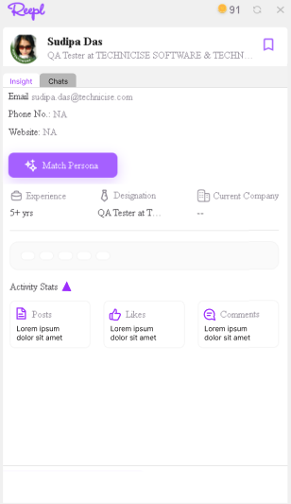

Figure 3.2. Profile Checking – Redesign

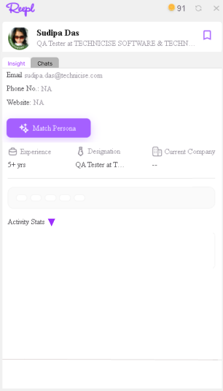

Figure 3.3. Profile Checking – redesign- Activity Stats

Friction Points: Insight and Chats Tabs are not perceived as tabs, they are perceived as buttons, which leads the user to believe that they will be redirected to another page.  
Email, Phone No and Website do not always get parsed by the Ui, and they are not visible enough. Experience, Designation, Current Company, Posts, Likes, Comments - make the user think that they are not available as information, as they are grey and the contrast is not high enough. Activity stats information can overflow the box given. Refresh options do not work on most models, and the system does not always parse all the information on the LinkedIn profiles.

Solution: insight and Chats can be displayed as Tabs, so the user understands that those tabs can be toggled. Personal information should be displayed in bolded, as it has a high importance for the user. Experience, Designation and other subtitles should be bolded and the font colour should be darker, making this more visible to the user. Additionally, icons can be made purple so there is more consistency in the Ui design.

I suggest having the Activity Stats only available as a visible-nonvisible menu, as the information provided can clutter the space. I also suggest having only part of the characters available for those tabs, as comment and post sections can have a lot of text; these sections also suggest marking the information after X characters have been filled with ‘…’ so the space is not overflowing but also the user can see more insights by clicking on the sections (the user is most likely to look into those sections)

One overall suggestion that I have is checking some of the functionalities for the models, as features such as Sync, match Persona, Insight info etc do not work for most profiles that I checked.

**Additional suggestions:**

An option that can make the user’s experience more intuitive and easier would be combining all the tools offered by the Reepl extensions into one. While this option is a better approach for the user, it has to be planned with the front-end code and the way the interface has been done in mind. After having all the information needed we can proceed with implementing a solution that is even better for the user.

I will happily help with improving the UI for Reepl, as the user experience is one of the most important factors in making an intuitive and easy-to-understand design for every user and target group.  
  
Thank you for checking my suggestions and I will gladly collaborate and use my expertise in the Reepl UI/UX team.

Warm regards,

Prithwish Saha